**SOP – Pulling Permit on PPRBD**

1. Graphical user interface, application

   Description automatically generatedLogin to PPRBD
   1. You will need access to LastPass to login. The password is documented in the LastPass account.
2. On the Dashboard, click Permits, then click Search Permits on the next page

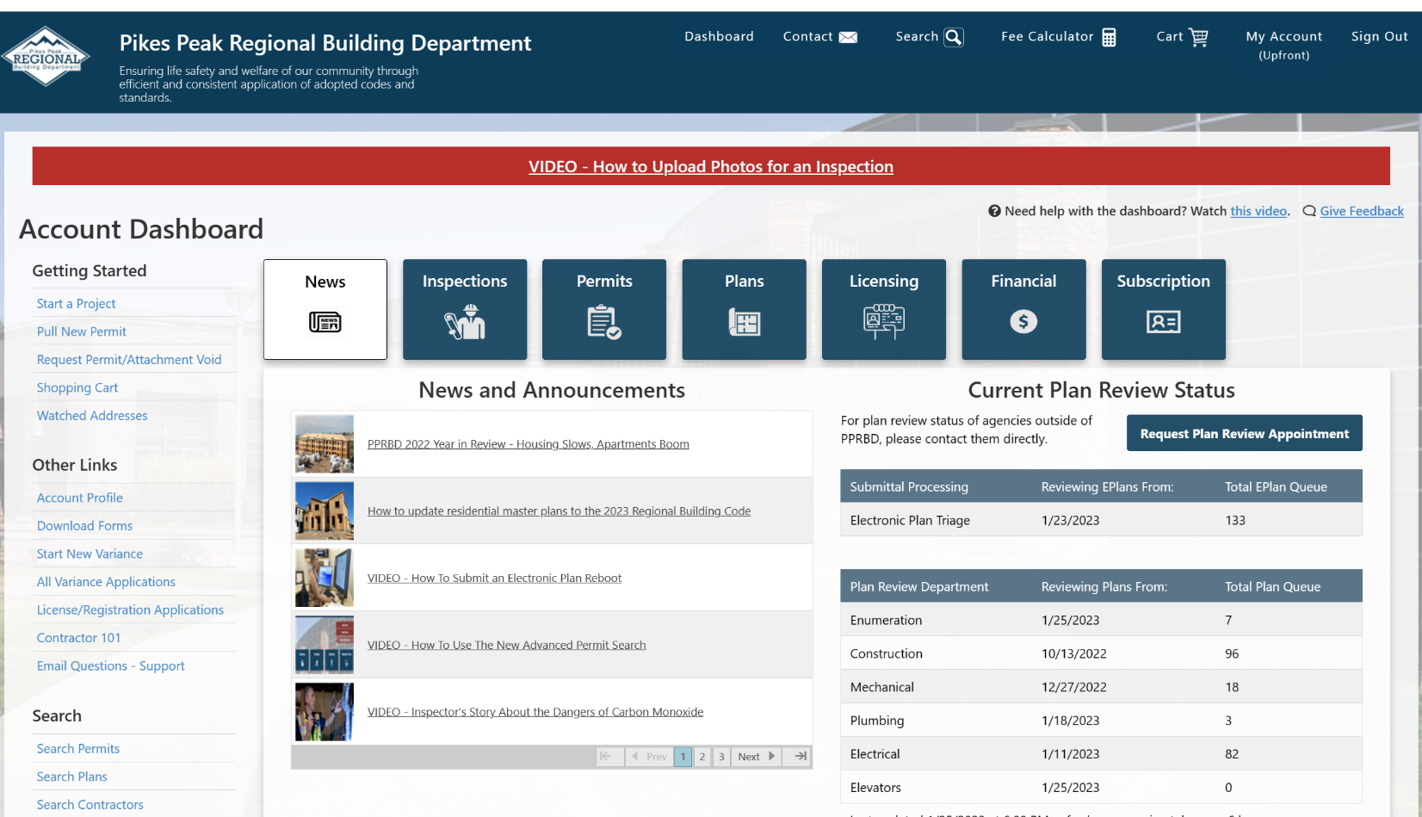

1. Graphical user interface, website

   Description automatically generatedClick on Pull New Permit
2. Graphical user interface, application

   Description automatically generatedFill in the dropdowns.
   1. Select Building
   2. Select New Permit
   3. Most of our work is Single Faily Dwelling
   4. Look at the total amount for the project in AccuLynx. Input the total job amount into Project Valuation.
   5. Click **Continue**.
3. Fill in the address information.
   1. Careful with this step, as it is kind of an odd way to enter an address. Example address: **4567 W Kiowa Dr.**
   2. Street numbers require only the numbers 4567.
   3. For the Direction dropdown, you will select ‘W.’
   4. Street Name would be Kiowa.
   5. Street Type would be ‘Dr.’
   6. Click **Continue**.

1. Input the owner’s phone number.
   1. Use the phone number in AccuLynx.
   2. If the job is for a Property Manager, then use the property manager’s phone number.
2. Select a Standard Project.
   1. This field has limited options. Choose the appropriate option.
3. Provide a short description in the Customer Project Description box.
   1. This description is literally short. If we are replacing the roof, enter reroof. If we are doing gutters as well, add gutters.
   2. If we are painting, replacing windows, or doing some interior repair because of water damage, there is no need to mention those. We don’t sweat the smaller stuff.
   3. If you have any questions, just ask your supervisor.
4. Finish by clicking **Add Permit to Cart**.

1. Choose “I am not interested” for any option that adds cost to the permit.
   1. We do things outside of this permit to help people; therefore, we don’t give here. As an example, we offer seniors that we work with a discount on work.

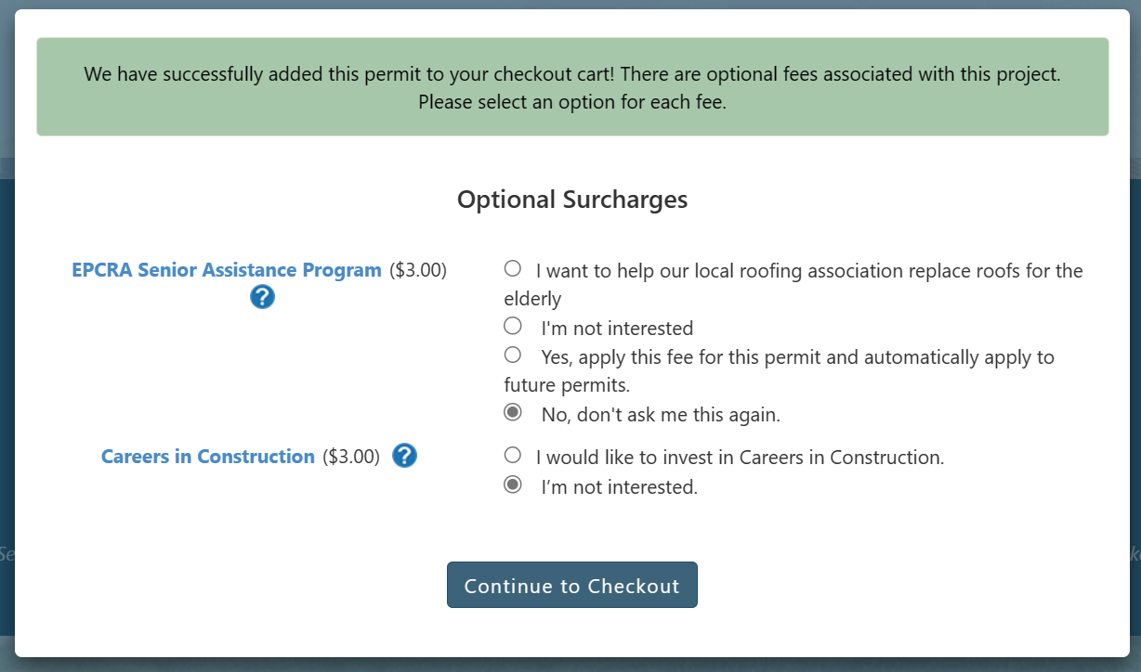

* 1. The Optional Surcharges you see may change, so the screen may look different than the snippet in this document.
  2. You may select, **No, don’t ask me this again** if the option is available.
  3. Click **Continue to Checkout**.

1. Choose a tax status.
   1. Always pick “Affidavit” because we pay taxes on materials when buying them.
   2. Click **Proceed to Checkout**.

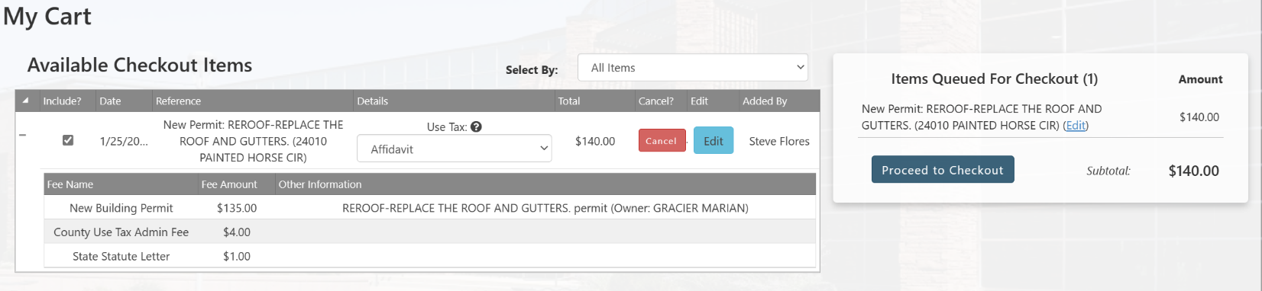

1. Choose the Elan Business Card.
   1. Enter the 3-digit number for the card. If you do not have the 3-digit number speak to your supervisor.

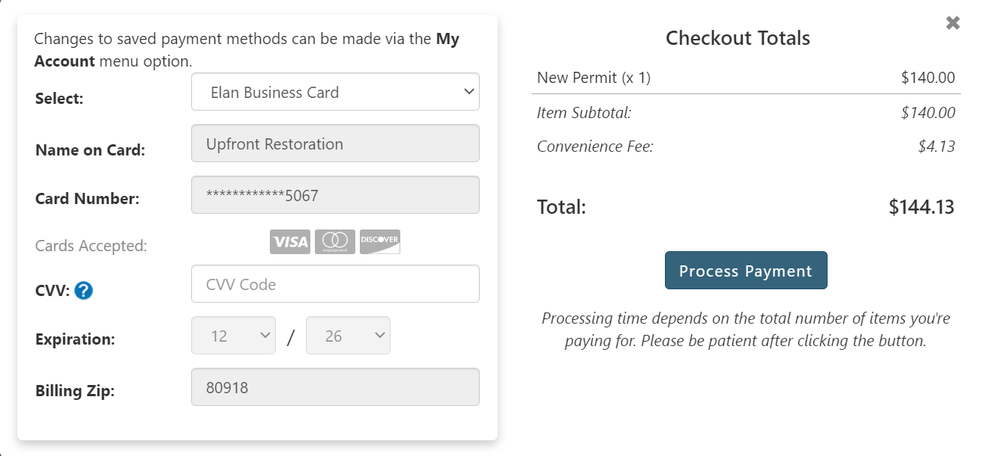

1. You will know it worked by the green bar across the top of the page.



**Requesting an Inspection for a Roof with Solar Roof Panels PPRBD**

Tom from PPRBD said:

For Solar Roofs, they make special inspection requests   
- Within 14 days  
- Request solar inspections via the PPRBD Website and add 'Solar Roof Top – please be advised' in the comment box. They will inspect sooner than usual. No need to call it in. Hooray!